NEWSLETTER OF THE ZONTA CLUB
OF BUNDABERG INC.
QUEENSLAND -AUSTRALIA

“Advancing the Status of Women Worldwide”
Club No 1296 Area 4 District 24
Charter 24.08.90

Postal Address: PO Box 431
BUNDABERG 4670.

30 August 2004 Vol 7, No 8.

President: Carol Christensen Secretary: Christine Francis Editor: Dianne Leggo
Home Ph: 07 4154 5455 Home Ph: 07 4153 6713 Home Ph: 07 4154 7958
Rendezvous@interworx.com.au Work Ph: 07 4150 2700 dleggo@dodo.com.au

DINNER MEETING

The September meeting will be held at the Rowers’ Club, Quay Street at 6.30pm for 7.00pm on Tuesday 7 September. The cost of the meal will be $20.00 and drinks can be purchased at the bar. Apologies received after 10.00am on the day of the meeting will not be accepted. Members making late apologies or no apology will receive an invoice immediately after the missed meeting for the cost of the dinner.

Apologies are to go to Wilma Berry. Her phone number is 4151 5246. Her email is berrywine@itxpress.com.au.

All members with dinner meeting arrears, please pay at next dinner meeting.

September rosters:
Door: Lyn Costigan and Robyn Dyer
Zonta Blessing: Tina Wallace
Raffle: Anne Nelson

Birthdays September:
Judy Bedford – 8th, Linda Adcock – 15th, Carol Christensen – 18th,
Christine Murphy – 26th.
Dates to remember
October 24 UNIFEM Spring Walk in Bundaberg Botanic Gardens
November 6 Zonta Bus Trip to Eumundi Markets and Montville with a
surprise lunch venue.
February 26/27 2005 Area 4 Meeting

CONVENTION ELECTION HIGHIGHTS
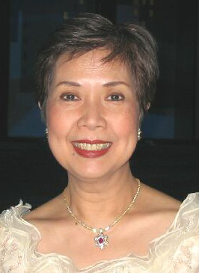
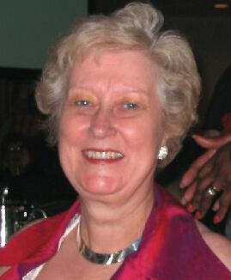
Olivia Ferry from the Philippines was Beryl Sten from Sweden was
elected International President Elect at elected Zonta International
the recent Convention in New York. She Vice President in New York. She
was International Chairman of Organization was an International Director in
Membership & Classification in 2002-2004 2002-2004 and 2002 Convention
and International Director in 2000-2002. Chairman in Sweden.

WEBSITE NEWS – International, District & Club

www.zonta.org
Register now! Join thousands of Zontians around the globe in the organization’s largest web site registration campaign. Zonta International’s goal is to have 14,000 members registered by 31 May 2005. Clubs and districts with the most registered members will receive special recognition on the web site and in The Zontian magazine. Will you help to have Bundaberg Club recognized?

Just go to www.zonta.org and follow the instructions to register. You will need your membership number – see the wrapper on your Zontian magazine or ask the Club Treasurer or Membership Chairman. When registered you have access to lots of interesting information on the Zonta International
Website.

www.zontadistrict24.org Click on Join Now at the top right of the page to register.
Club Chairmen, have you contacted your District Chairmen yet? They love to hear what plans clubs have for the Zonta year. To find their contact details click on Newsletters & Governor’s Memo, then June 2004 Newsletter.

www.bundaberg.zontadistrict24.org View our new club website – thanks to Tina Wallace. Be patient as the club newsletter and website are new challenges for Dianne Leggo.

Advance notice possible service project

It would be helpful if members could look at the “National Zonta Birthing Kit Project” attached to this newsletter. We may be discussing this project at our next club meeting on September 7th.

Finance Committee news:

The Committee has decided October 16th for the Garden Party does not allow the time to organize our usual high standard function. This event is therefore cancelled for this year and will be reassessed considering time and effort versus money raised. The Committee is looking at the alternative of another Golf Day in May 2005.

September meeting:
- Bus trip to Eumundi Markets - expressions of interest will be sought
- Wine orders will be taken for delivery at the November meeting, in plenty of time for Christmas parties and presents for staff, family, friends.
Think about stocking up!

Club News
- Great to see Denise Tomlin, Margaret Gibson & Desirae Kirby at our last meeting. Best wishes for continuing recovery to good health.
- Dianne Leggo attended the charter dinner of the Zonta Club of Middle Harbour at the Manly Pacific Hotel in Sydney on 16 August.
- Kym-Marie Bush is presently overseas. Happy travelling Kym-Marie!
- Jean Gahan has been organizing local tours for a group from Sydney.
- Good luck to Denise Powell with her long bike ride next month. Ride safely
- Denise!

BOOK NOOK
While overseas, I saw an exquisite film “Girl with a Pearl Earring” which was set in Delft, Holland in 1665 and was about artist Johannes Vermeer. Someone then lent me the book which I loved and to top it off, I found a DVD of the film to bring home. I’m happy to lend it out but it needs a DVD player that will play discs from overseas.

I also read “A Woman of Independence” by Kirsty Sword Gusmao, (Australian) now First Lady of East Timor and guest speaker at the charter dinner of Charters Towers. What a courageous and inspirational young woman. (Dianne L)

