

The Metro

Zonta Brisbane Metro Breakfast Club Inc.

Issue 28
7 June 2006

Visit to Grevillea House
A

On Saturday, 20 May, Cath, Sarah and I paid our monthly visit to the girls at BYDC (youth detention centre). As discussed at our last meeting, we had decided to abandon our attempts to hold an exercise class, and had spoken with the Centre Management about joining in whatever programs were organised on the day for the girls. And we struck a gem this Saturday!

The girls were undertaking a Personal Grooming program with Tracy. They spent about 40 minutes with Tracy in groups of about five, where they have access to all sorts of beauty, make-up, hair and nail products. Sarah got into blow-drying with one of the girls (I’m sure there’s a name for that flick-up style of hair-do that she did so well), Cath tried her hand at braiding (and discovered it is totally different doing someone else’s hair from reaching behind to do your own!), and I painted nails (must take my reading glasses next time, so I can see what I’m doing to the poor girls!).

There’s no doubt that the girls were doing something they enjoyed, and they were perfectly happy for us to join in with them. Also, having them in smaller groups, even in the fairly

small room we were in, is a lot better in terms of communicating with them.

We all left the Centre feeling very positive about what had happened, and fired up with some ideas of how we could contribute some more.

The hair dryer that Tracy has access to is old and a bit clunky (they couldn’t turn it off ‘cos it might not start again!); she has a hair straightener, but it doesn’t work; and there was a radio playing in the room, but the reception was terrible. We thought that we could get a new hair dryer and a ceramic hair straightener, and maybe a portable CD player – all of which would remain in Tracy’s custody for the personal grooming sessions.

Club members recently voted to allow us to spend $60 per month for a personal trainer for the girls. We are now asking your permission to spend some money to acquire the above items for the girls. The Program Co-ordinator at the Centre has agreed to schedule Personal Grooming for the girls on each Saturday that the “Zonta ladies” visit Grevillea House.

Rita Logan

Board members for 2006/07

President Committee Chairs:
Elaine Harrington Status of Women & Service/UN Sarah Gray
Vice President Organisation, Membership & Classification Amena Reza
Amena Reza Public Relations Jan Mohr
Treasurer Correspondence Secretary Jan Mohr
Rita Logan Minutes Secretary Kate Hill

Directors Loris Neff, Susan Taylor, Cath Cosser, District 24 Club No: 1624

Area 5: DIRECTOR: Vicki Varthas GOVERNOR: Ros Kinder Website. www.zontadistrict24.org

President’s Message

As this is my first message as President, may I welcome you all to our June 2006 edition of The Metro. Our newsletter is in the very capable hands of Michelle Wells for another year.

Last week the Joint Board held a handover meeting over dinner at my home to welcome new members Susan and Kate Hill, and also to farewell and thank resigning members Terry and Kate Farrell. Loris, unfortunately was unable to attend. Celeste, as Past President is also a member of the Board, and I will appreciate her ongoing advice and support in the coming year. I am delighted with the composition of experienced and new members of the Board, and look forward to continued relationships and forging new ones as we work together for our Club in the coming year.

A committee sign up sheet will be circulated at our June meeting. Please choose the Committee you would prefer to join for the coming year. The Membership Committee will then review to ensure that we have workable numbers on each committee.

The Convention motions to be debated at the biannual International Convention have been circulated by Celeste. While there are 22 in all, many appear to be to clarify or correct. The Board has discussed all 22 and of these only 3 (9,16,17) would seem to be issues that would attract debate, and propose that we discuss these 3. If after reading the document, you feel you would like to discuss any other motions, please bring up at the meeting.

On Wednesday 17 May 2006 Cath Cosser and myself attended All Hallows’ School assembly to present Jennifer Rowlands with her certificate and cheque as our Club’s winner of the Young Women in Public Affairs Award. Our presentation followed a moving Mother’s Day tribute to Mothers and all women dedicated to helping women. I presented a short address on Zonta International, our Club, the YWPA Award, and Jennifer’s application before calling Jennifer to present her award before the assembly. We hope this exposure will create a familiarity and acceptance of the award and thus encourage more applications in the future.

Thanks to our Club Members the Da Vinci Code fund raising film night was just short of a complete sellout. Many thanks to all who helped out on the night, especially Flora who will forever have the title of “The Raffle Prize Queen” for her talent in obtaining raffle prizes, and Geraldine for tackling the enormous job of managing the ticket allocation! (Pics to follow pg 3).

Elaine Harrington

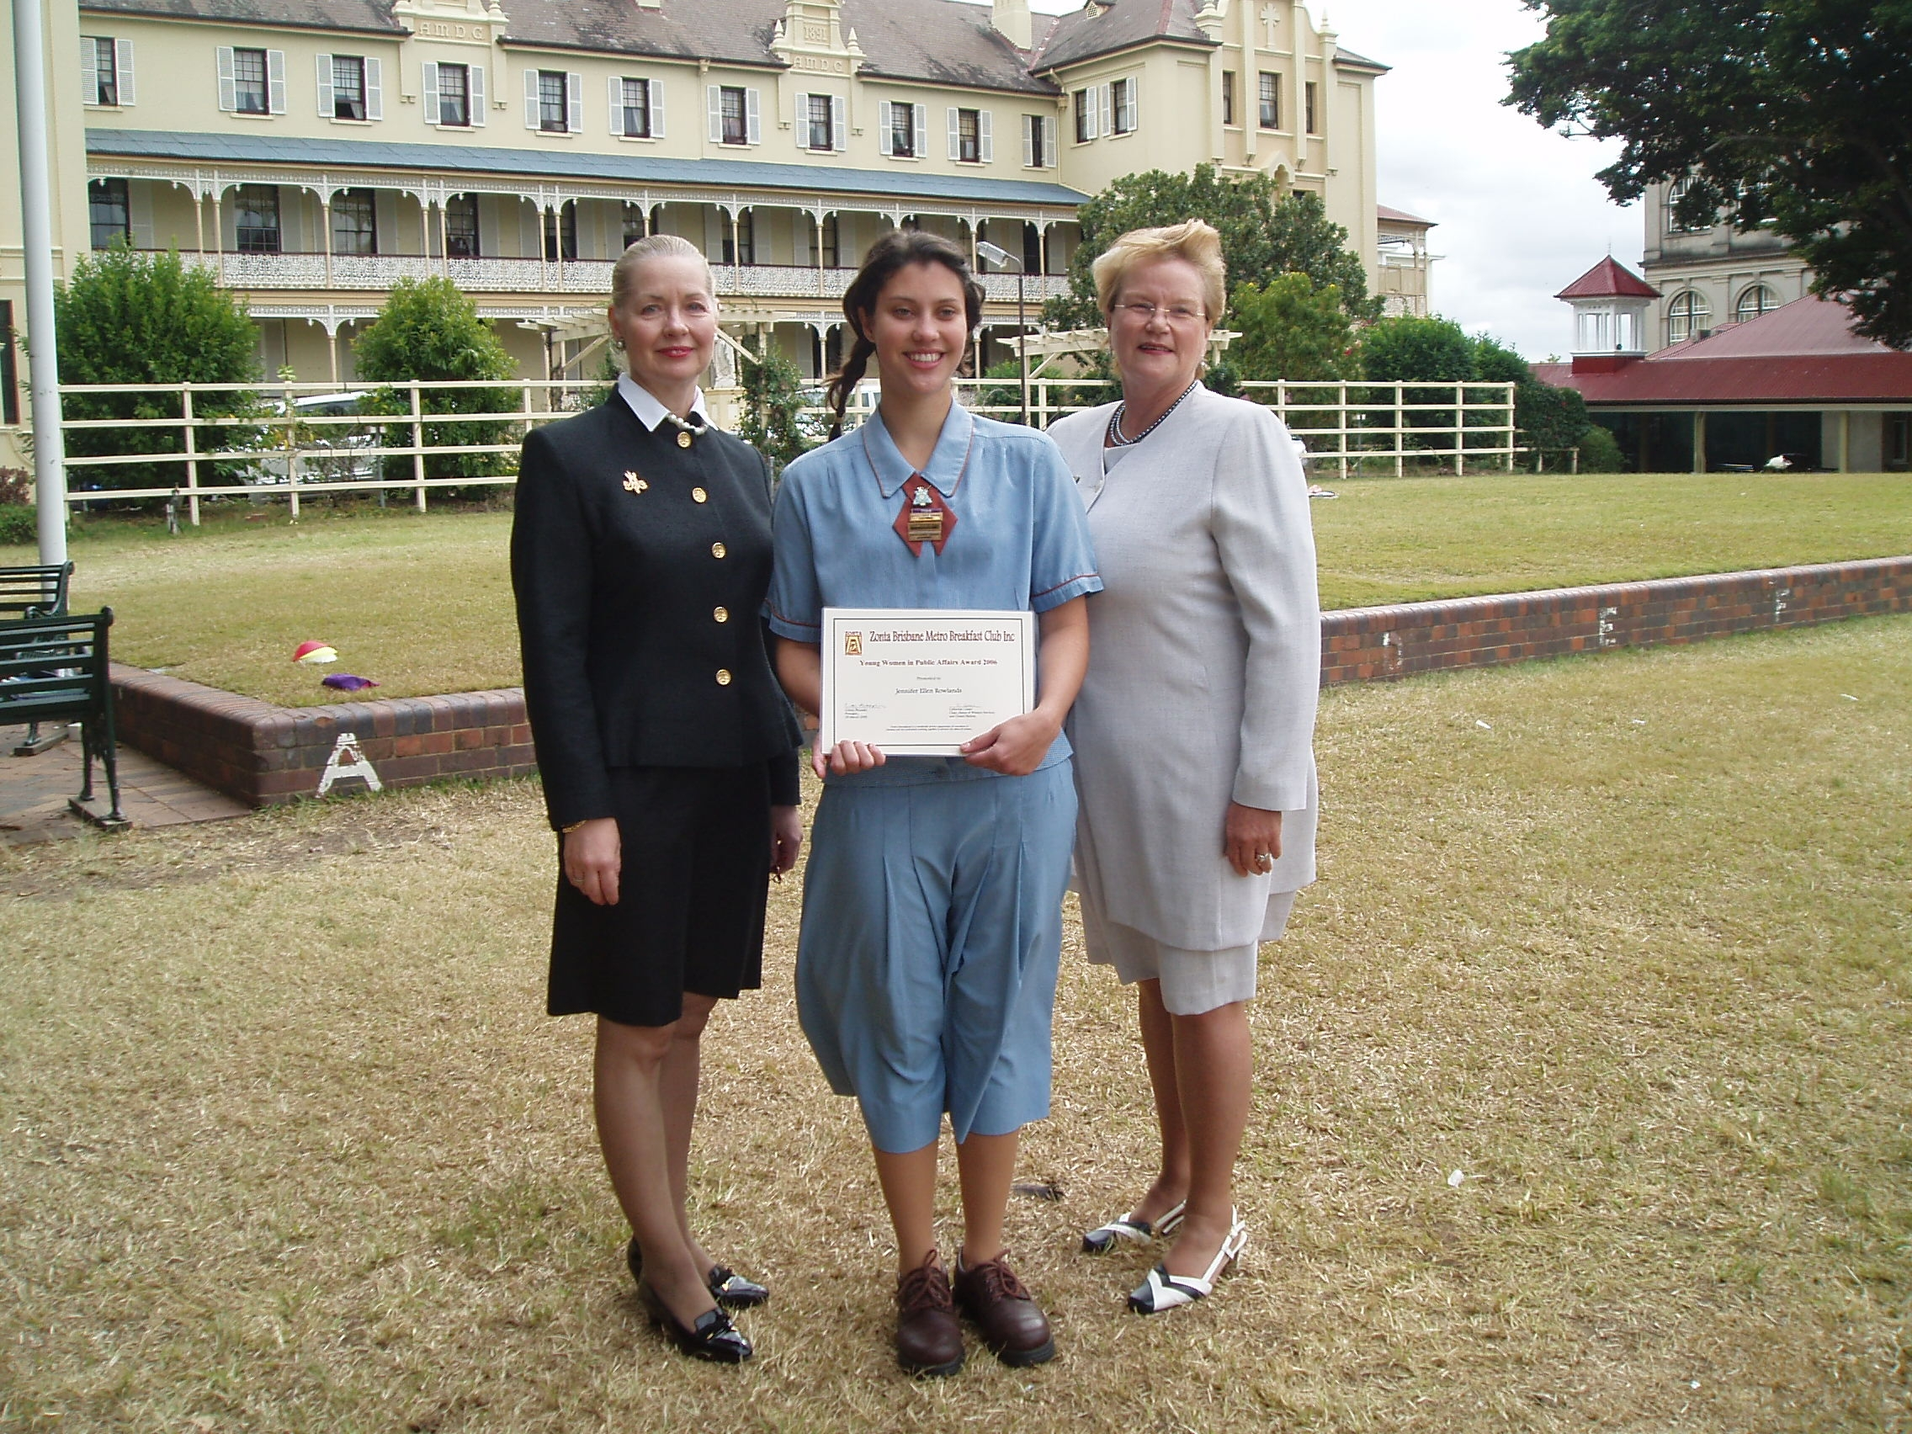

Cath and Elaine present Jennifer with her award at All Hallows
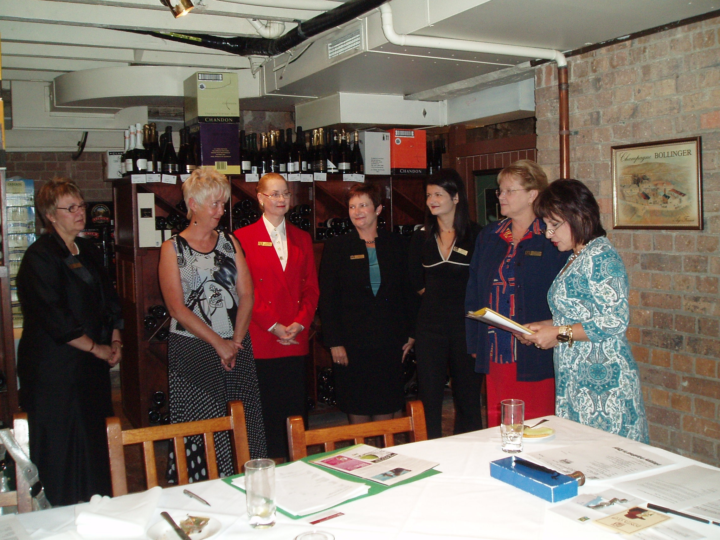

Installation of the new board (LtoR) Loris, Rita, Cath, Jan, Amena, Elaine

Anglican Women’s Hostel News

We recently received the Hostel’s May newsletter which serves as a great reminder of the wonderful work being done at the Hostel and how our Club plays a role in contributing to this. Here is a brief extract.

“We have experienced a very busy month. The hostel is full to capacity and we are forced to turn away homeless women each day, NCDA reports state we are currently turning away 60% of all requests for housing. This is an appalling figure and not only reflects the needs in the community but also echoes the frustration of staff and powerlessness of all concerned.

The hostel is running smoothly thanks in large part to the case management team and the overnight staff. The overnight team report a lessening of incidents, which makes for a better outcome for daily case management.

We are cautious about being “lulled into a false sense of security” as we all recognise our client group represents fragmented women in crisis and we have, and will continue to have, incidents, however the presence of the 24 hour staff prevents these incidents from escalating into critical incidents.

May is traditionally a difficult time for most of the residents. The weather is getting cooler, days shorter and Mother’s Day comes with its share of sadness and loneliness.

We were able to arrange a boxed gift for all of the residents on our Mothering Day, a sausage sizzle for lunch and pizzas and ice cream for dinner – so all in all, a sad day full with unexpected treats and surprises!

The Homless Outreach Team (HOT) has been holding a clinic at the hostel weekly for the past siz weeks. The support that they offer to the residents and staff is very welcomed and they work from an empathetic, relationship focussed framework. We are able to discuss problems and issues with them.“

to our June birthday girls Caroline Austin, Robyn Martin and Annette Baird. Best wishes to you all for a happy day.

Da Vinci Code photo gallery


Vicki and guests (the generous donator of the huge Toblerone is on Vicki’s right!)
Da Vinci Code photo gallery
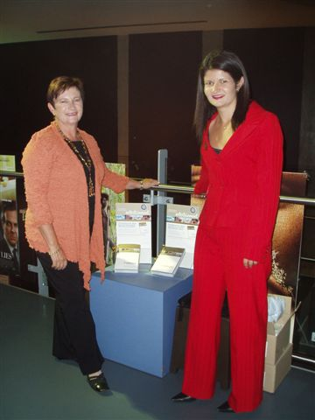
Amena and Jan scouting for business

