ZONTA CLUB OF MOUNT ISA Inc Newsletter

P O BOX 2442, MOUNT ISA QLD 4825

President: Linda Harrison Wk 4743 6733 N/Letter Editor: Liz Ryan
Vice President: Michele Savoye Any submissions to N/Letter email to Liz Ryan - MIPP@bigpond.net.au
MAY 2005

President’s Patter

Hello Ladies,

AREA 7 WORKSHOP !
Phew, all over, and wot a great time.

DG Ros Kinder was gob-smacked at how great our Area 7 Workshop was.

We had 16 ladies from the coast come and join us, and they all agreed. You can’t outdo the Isa Zontians.

Big thank you to our intrepid organisers. Liz and Kristen for their organising of Mercure Verona. Shannon, Maria and Sarah for their organising of the Saturday Night function (Buses, entertainment, decorations) and the games through the Workshop.

Michele Savoye for her beautiful pottery which graced the front of the Gift Boxes. Cherry, who manages to be everywhere at once and fills in the gaps as required. Sonja for a delicious meal on the Saturday Night (boy, did that make us look good.)

Leonie Moore and Sue Carson for their running of sessions through the Workshop.

It was a great combined event. The Breaky Club were terrific (as usual). Paula’s input could not be beaten. With the shirt stitching, bookmarks, and that beautiful quilt!

Gosh, we’re terrific!
If I’ve managed to miss someone, it is unintentional, and I hope you will all forgive moi.

Photos to follow in the next Newsletter. Am still waiting for photos from Michele. It seems our other photographer had a fight with her camera, and well, some of the photos aren’t too good. OK, I’ll be truthful they look like we were underground. (Bloody new technology! Who knows what the hell you’re doing with it.)

PCYC – MEGA DAY OUT – SATURDAY 9TH APRIL

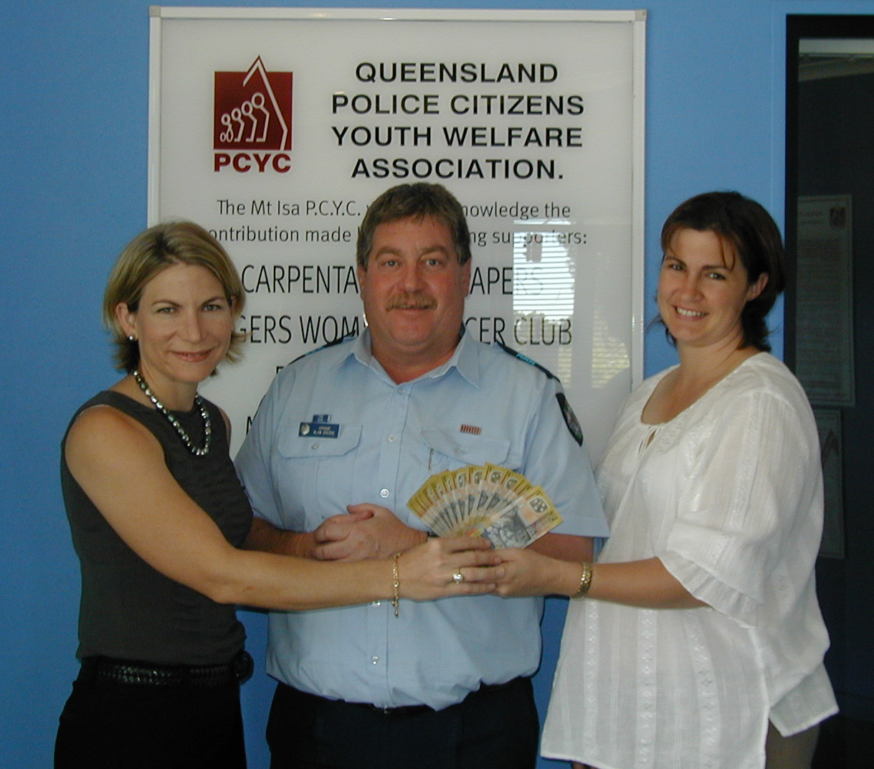
Joyce McCullough (Breaky Club), Alan Dredge (PCYC), Shannon Ward (Our Club)

We managed to donate the $1000 we earned at the PCYC Mega Day out.

Interesting to note, that Zonta is the only organisation at Mega Day Out who donated the hard earned cash back to PCYC. Alan’s, really happy that we do it. (Every little bit helps!)

ONYA LADIES!!
.
WHITEGOODS FOR SERENITY HOUSE
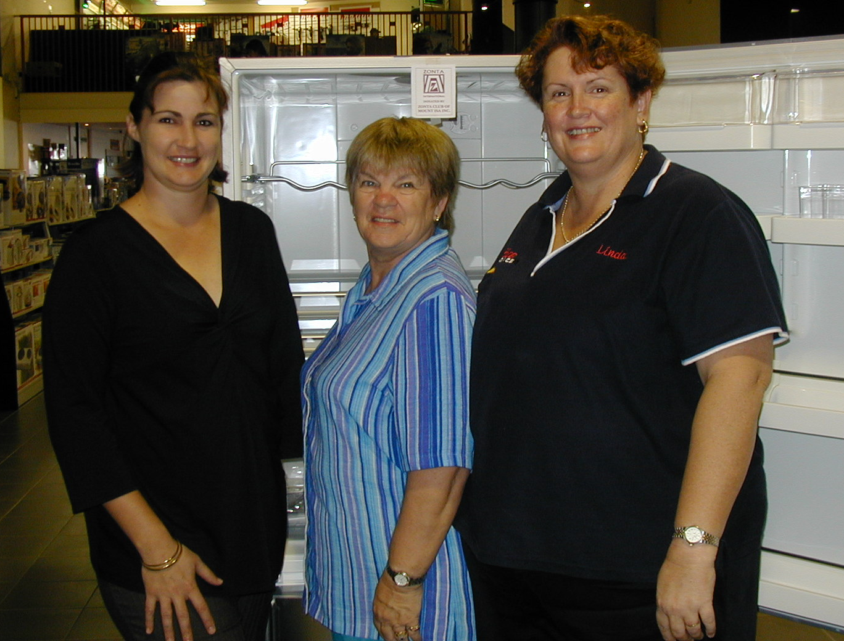
Shannon, Sue Shield (Serenity House) and moi.

We made the donation of Whitegoods to Serenity House on the Thursday before Area 7 Workshop. Serenity House will physically get the cheque next week sometime. (Books at the auditors)

They were stoked to receive such a great gift. And we have received a thank-you card already.

MAY MEETING – 18th May
May meeting is our AGM, and Changeover night. YEH! Michele is at the helm from here on in, although, I do have a 1 meeting fill in. I’ll be at the helm for the June meeting cause Michele is off to France to see her Mum. All those who thought they were getting rid of moi, sorry! Just 1 more meeting to go.

So, will get to rabbit on to you for one more newsletter. Come and say thanks to the outgoing Board. We’ve had a bonanza of a time, and they deserve your support.

See you there!

ZONTA ON!!
Linda Harrison
Soon to be EX-El Presidente.

OUR BIRTHDAY GIRLS
FOR THIS MONTH ARE!

CAROLYN HAY MAY 02
MARILYN JACOB MAY 02
ANNE CUNNINGHAM MAY 03
MAUREEN SWEENEY MAY 03
SARAH FRASER MAY 04

AGM
The AGM will be held on the 18th of May 2005. Could all members note this in their diaries.

Next Meeting
Wednesday, 18th May
Terrace Gardens
7pm

THOUGHT FOR THE MONTH!

A MAN’S GOT TO DO WHAT A MAN’S GOT TO DO. A WOMAN MUST DO WHAT HE CAN’T.

RHONDA HANSOME

