

The Metro

Zonta Brisbane Metro Breakfast Club Inc.

Issue 22
5 October 2005

Brisbane Metro Breakfast Anniversary Dinner
A

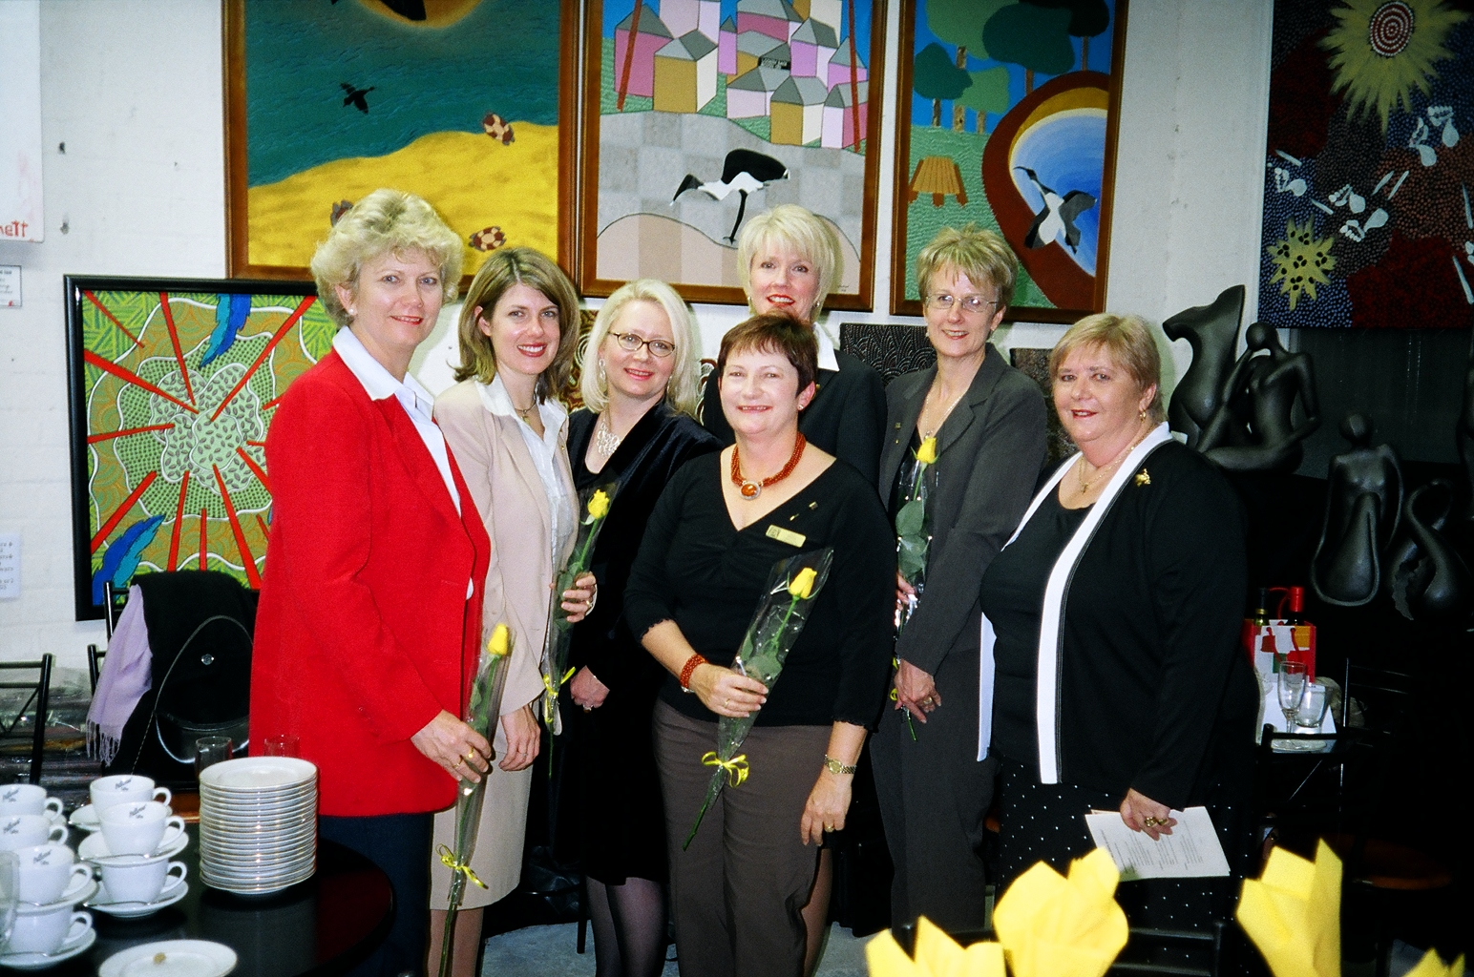

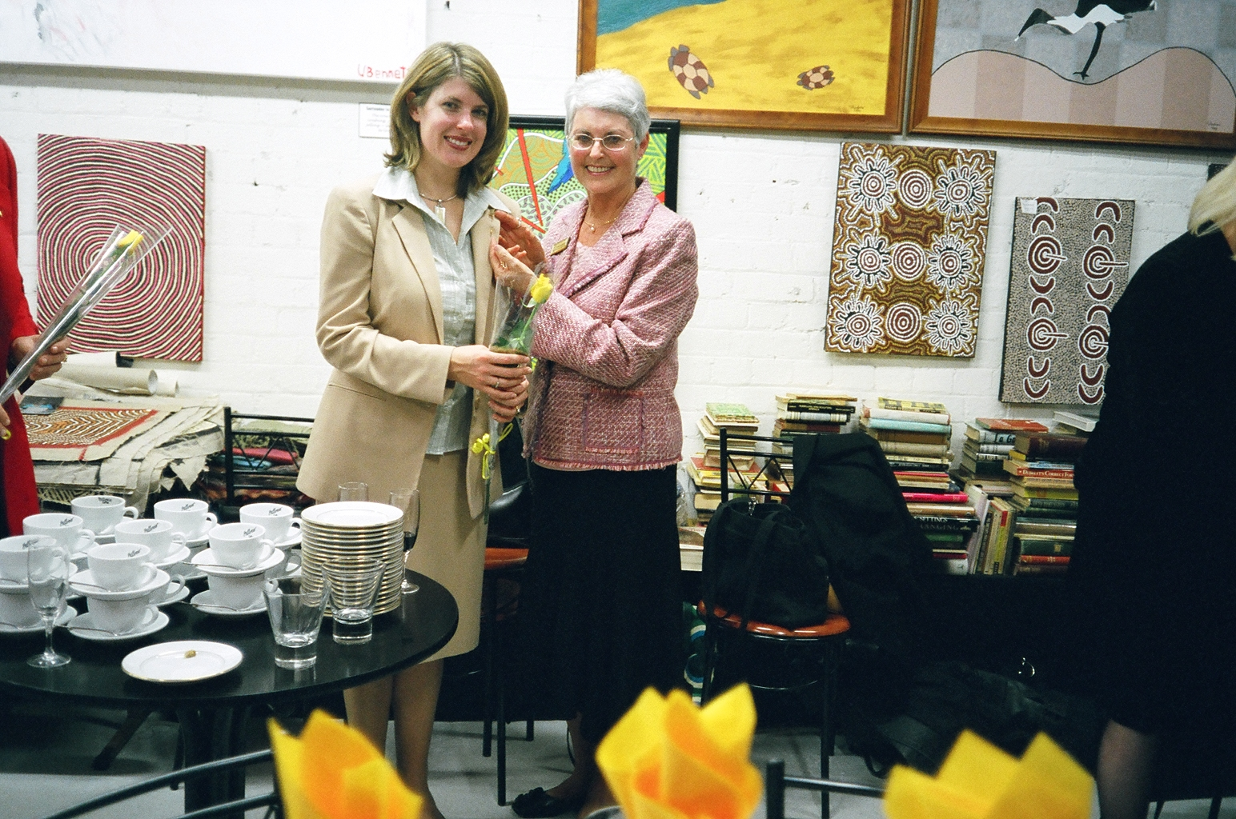

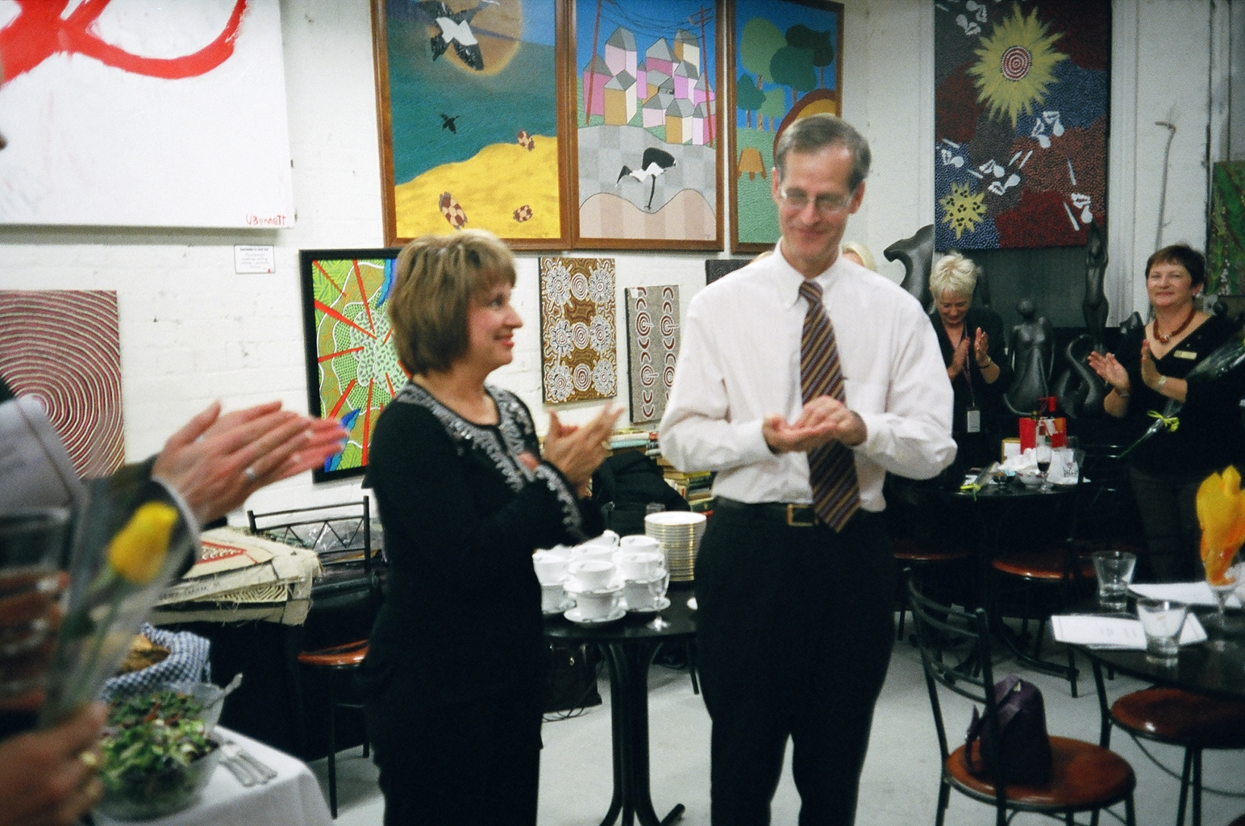
Vicki and our newest HonZon Phillip

A wonderful night of food, fun and reflection was had by all on 27 July to celebrate our Club’s anniversary and induct the new members for the year.

The party was held at Brilliant Facets in Mary Street – a shop filled with some fascinating books, jewellery and artefacts….which also doubles as a restaurant – with catering by the well-reknown Mary Kios (of Mary K Catering).

After some drinks and nibbles on arrival, Celeste welcomed the group and reflected on the activities and successes of the Club during the past 12 months. Our District Governor, Ros Kinder, then carried out the honourable duty of inducting the five new members to the club and presented them with their Zonta pin and rose. Michelle was very touched when Ros invited her mother and past Area Director, Diane Harmsworth, to present her with her pin and rose. Finally, our very own Area Director Vicki officially announced Phillip Cosser (Cath’s husband) as an HonZon (Honourable Zontian) of our Club and presented him with an HonZon pin.

With the formalities over, Elaine said the Zonta Grace and we all sat down to enjoy a delicious meal fit for a king (or three)!

Top right: The five new members Debbie Kember, Michelle Wells, Robyn Martin, Jan Mohr, Liz Clewes. Middle right: Michelle and mother Di

Board members for 2005/06

President - Celeste Neander Committee Chairs
Vice President – Elaine Harrington Status of Women & Service/UN – Cath Cosser
Treasurer – Rita Logan Organisation, Membership & Classification – Correspondence Secretary – Kate Farrell Amena Reza
Minutes Secretary - Terry Creagh Public Relations – Elaine Harrington
Directors – Cath Cosser, Amena Reza, Jan Mohr

District 24 Club No: 1624
Area 5: DIRECTOR: Vicki Varthas GOVERNOR: Ros Kinder Website. www.zontadistrict24.org

Undercover Profile: Debbie Kember

When asked for a member profile by Michelle I immediately thought of the CSI theme – Who are you …..well thankfully we don’t need forensics to determine that at this point but the best place to start may well be with a few tags like post-modern feminist minus the extremist bits, rarely fit fitness junkie, possessed golfer, online inhabitant bordering on compulsive when building web sites, inner city high rise dweller whose next home will be on the ground, happily married gal with a wonderfully tolerant husband of 23 years (as long as he doesn't get called David Kember!!!!!), happy traveller – holidays only – got over the work travel thing, many times beaten but not bruised Senate candidate, true believer type volunteer in teacher professional associations and budding bureaucrat.

The career part of the story started with a dream to be a tennis professional and play at Wimbledon –well did get there this year but not to play tennis. Instead I became a Health and Physical education teacher with the vision of helping every student to learn an activity that would keep them healthy and happy beyond their school years. Well - I heard every excuse in the book during my twenty years in schools but to this day I still enjoy a chance encounter with former students.

Since making the big move from a secure, safe, stable job in a pleasant school I have worked as a university lecturer and research officer. I have started a boutique web design business, worked in a multimedia company and since 2002, when I was invited to help Education Queensland staff set up an online learning environment, I have meandered through the Department of Education and the Arts exploring the machinations and mazes of the public service.

Just last week I signed up to start a doctorate next year at QUT and am interested in looking at the preparation and pathways of pre-service teachers. So all in all I like to do lots, keep moving forward, laugh at the mad bits and share it all with my husband and friends.

Debbie

A breakfast meeting not to miss….

Remember to mark your diaries for our Christmas breakfast on December 6th

A great time to relax and enjoy each other’s company, over a delicious breakfast and a glass of bubbly.

Venue will be advised shortly....

Do you have a friend or colleague interested in joining Zonta?

Bring her along to our next
Members Information Evening

13 October 2005
at the offices of
ML Design
Level 8 200 Mary Street Brisbane
5.45pm for 6pm start

RSVP to amena.reza@mldesign.com.au
by 10 October
Happy Birthday
 

Many happy returns on 26 October

to this month’s birthday girl

Geraldine

 

Status of Women and Service

On 15 September Rita, Cath, Sally, Sarah and Amena visited the Youth Detention Centre for the second time.

On this occasion we met the five girls in detention. The visit was arranged with the Centre management, in order for us to meet with the girls and have discussions with them about ways in which we might provide them with some useful support.

The initial part of the meeting was awkward as neither the girls or ourselves knew what we expected of each other. In order to break through the barrier we showed the girls the birthing kit folder and that stated a conversation about the schooling they received while inside and also what they wanted to be when they got out of the detention centre.

Several things did emerge from a discussion that started off a bit stilted, but got into groove when both groups relaxed a bit. One issue that is concerning the girls is health and fitness – there is plenty of food at the Centre and nearly all of them have put on weight since being there.

The girls have noticed that some of the boys at the centre had started doing gym work and had become "quite hot". But they did not wish to go to the gym as it was on the boys' side and fitness activities tend to hinge around the more male pursuits (since the girls are seriously outnumbered by boys in the Centre).

So on Saturday, 15th October, the same group of Zontians will take an aerobics video out to the Centre and…yes, we’ll do it with the girls! It probably won’t be pretty (can’t tell you how many years it is since I did any aerobics), but it will probably be a lot of fun.

We plan to leave the video with the girls in the hope that they will continue on their own to do aerobics sessions until we go back for another workout. (which will be some weeks after or until our bodies stop aching!).

If they reach their target then around Christmas time we will arrange a glamour shoot for the girls.

Another issue that came up was the type of jobs that the girls would like to have in the future, and possibly we could provide some sort of advice, or an expert in the field, around particular careers to provide some guidance about what is required. We will explore that idea further in coming weeks.

Now that the ice has been broken, we will continue to liaise with the Centre staff and the girls about ways we can work together to improve their futures.

Cath and Rita

Organisation, Membership and Classification
The OM&C Committee has presented a proposal to the Board for a fund raising event to be held on 20 November at Jade Budda (the trendy new bar that has replaced City Rowers nightclub). From 1pm – 5pm guests would be entertained by Brisbane band Phoenix. Tickets $20 for a BBQ lunch or $10 only for entertainment. The committee is awaiting final approval to proceed following this morning’s meeting.
The Committee has also been discussing an update of the New Members Information Evening presentation. The Committee would like to call for anyone who has interesting photos of fundraising events and other Club activities which may be useful in putting together the new format. Amena

Public Relations

The PR Committee has been discussing the format and content of a Club webpage to add to the District 24 website. A collection of pictures and past newsletters was also provided to the OM&C Committee for the New Members Presentation.
Elaine
Committee Reports

District Conference 2005

This weekend (7-9 October) the District Conference is being held on the Gold Coast. Thanks to all members for their input into discussion of this year’s conference Motions. Thanks to Amena and Loris who will be representing the Club as delegates this year. Best of luck also to Vicki, who is standing for election as Lieutenant Governor. Hope all other members attending find the conference rewarding. We all look forward to hearing your reports.

Tales from Gay Paree!

Bonjour mes amies,

Finding our way around Paris very easily and loving the location of our apartment in St Germain. Very central and amongst the most beautiful shopping areas in Paris. Have found the weather to be much warmer than our last visit (October 2003). The afternoon of our arrival (Thursday) was quite hot, although this could be due in part to the chaos that is Charles de Gaulle airport (sans air conditioning!). Friday of last week was also very hot, especially in the gardens of Versailles. We spent most of that day at Versailles - loved the gardens. Took us approx 2 hours to explore the grounds. The palace was just fantastic - elaborate, extravagant, self-indulgent. What an ego Louis XIVth must have had.

Spent Saturday morning exploring St Germain des Pres area. Heaps of art galleries and studios in the aptly named Rue des Beaux Arts and the most wonderful looking chocolate shop in Rue des St Peres. At 68 euros (approx. $120) per 500 grams, it would want to be! Went through Paris' first church ie St Germain des Pres - very impressive (also went to Mass here on Sunday). Rue de Rennes crammed with signature stores - Armani, Dior... to name but a few. Spotted the "in" crowd at Cafe les Deux Margots. Spent the afternoon at Monet's home in Giverny (about 1.5 hours drive out of Paris). Absolutely glorious colours in the garden closest to the house - a truly amazing array of plants and flowers. Learnt that the entire garden is dug up and replanted each November although always remains painstakingly true to the original. Saw lily pond and bridge in Japanese garden - can really appreciate where Monet derived his inspiration for a lot of his paintings. So many photo opportunities everywhere one looked!

After Mass on Sunday, headed up to St Sulpice. Very elaborate altar in this church - huge gold candle holders and an enormous timber crucifix. One very large shell on either side of the centre aisle for holy water. Incredible organ - magnificent sound. Could not locate the brass strip in the floor (as noted in The Da Vinci Code) - could not search more thoroughly as Mass was in progress. Next to the Palais du Luxembourg and gardens - very impressive and popular on the day as weather fine and mild and, of course, it was Sunday. The Senate sits here when in session - must be very pleasant. Montparnasse cemetery fascinating. The last resting place of many famous artists, poets and writers.

Visited the Louvre on Monday. Spent most of the morning in the Egyptian and Oriental antiquities sections - areas we did not visit last time. Later, viewed the Crown diamonds and then explored the Rubens Room.

Yesterday, we spent all morning and part of the afternoon at the "Musee de l'air et de l'espace" - loosely translated as the museum of air and aerospace - at Le Bourget. This was once Paris' international airport, however, since the commissioning of Charles de Gaulle, only a small part of it is still in use for private jets. It is principally a museum and also an exhibition centre from time to time. Amazing amount of aircraft from the very first objects to take to the sky (by some undeniably very brave souls) through to the 747 and Concorde. The rocket and satellite displays were also very interesting.

This morning, we headed up to Montmartre and walked amongst the street stalls and down past the night club/revue area. Afterwards, explored the Trocadero area where we sat and had coffee looking at the Eiffel Tower. Still wondering if the 13 euros (approx. $25) for 2 cups of coffee was worth it! Ah well, when in Rome...........or Paris.

Au revoir!

Celeste

