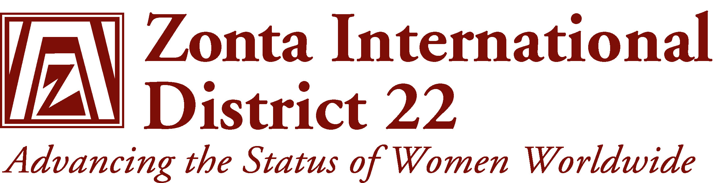
2008-2010

YWPA
&
Jane M Klausman
Awards
Guidelines

Young Women in Public Affairs
District Chairman
Ellen McGirr
Ph (Mobile) 0428 662 571
Email: emcgirr@wwwires.com

- Make sure that your Club uses the current Forms otherwise your nominee will be disqualified
- YWPA forms will be sent to Clubs in ZI mailing OR download them from - www.zonta.org
- Girls 16-20 years
- Girls must be pre-university or pre-college students at the time of application.
- Requirements are (subject to change):
- Signed Application Form by applicant
- Answer all questions
- 2 references
- Referees to sign Recommendation Form as well
- Complete Certificate of Enrolment
- A photo of the applicant
- Application must be typed
- Applicants should be made aware that the number of words stated on the form should not be exceeded.
- Commitment to volunteer sector
- Evidence of active commitment to volunteerism, evidence of volunteer leadership achievements & evidence of dedication to advancing the status of women worldwide
- At District/International judging, extra words will not be considered
- Completed original application of Club Winner must be sent to District Governor no later than 1st April, to qualify for District judging.
- Late applications cannot be considered due to time constraints for District and International judging
- The Club Winner must be judged on the written Application only.
- Interviews may be used, but the applicant should be aware that judging is on the written application
- YWPA District Winner receives $US500, International Winner $US1000

Jane M Klausman Award
District Chairman
Wendy Downes
Ph (H) 07 4946 5256 FAX 07 49465398
Mobile 0418 768 493
Email: thedownes@airlie.net.au

- JM Klausman forms will be sent to Clubs in ZI mailing OR download them from the ZI Website – www.zonta.org
- Correct (current) Forms must be used. Forms are subject to change so keep checking before asking for submissions.
- Girls in their third or final year of an undergraduate business-related program at a recognised University
- Volunteer and leadership activity essential
- The professional essay should identify knowledge of the field and a commitment to pursuing a career in this field & how this Award will assist in meeting these goals.
- Requirements:
- Typed application
- Current photo
- 3 confidential recommendations –
- 2 from University &
- 1 from employer/volunteer advisor/academic advisor
- Transcripts i.e. Academic results
- Outstanding academic record during first years of study
- Completed Verification of Enrolment Form
- Applicants should be made aware that the word limits for answers to each question should not been exceeded
- At District/International judging, extra words will not be considered
- Completed original application of Club Winner must be sent to District Governor by 1st July, keep copy for files.
- Late applications cannot be considered due to time constraints for District & International judging
- The Club Winner must be judged on the written application alone.
- Interviews may be used, but the applicant should be aware that judging is on the written application only
- $A750 District Winner, $US5000 International winner

Page 3

GENERAL INFORMATION

- Access the ZI Website – www.zonta.org and /or contact the District JMK/YWPA Chairmen to ensure knowledge and use of:
- Most recent application forms
- Most recent application requirements
- Deadlines (Club → District Governor)
- Set your Club’s deadlines in line with above
- Allow plenty of time for selection procedures
- Follow up missing information
- Make sure word limits have been adhered to
- Allow for possible need for revision of application
- Before judging ensure applications are complete
- Some Clubs interview applicants. Judges should not use the interviews to determine the outcome. At both District & International levels, only the written application is used
- Forward Club Winner’s original application to District Governor by due date (keep a copy for Club files)
- Clubs may decide to award their own prize/certificate
- For further information contact the District JMK/YWPA Chairmen, www.zonta.org, or District Governor

ZONTA INTERNATIONAL FOUNDATION

Remember when forwarding your service dollars to the ZIF that these Awards are funded from Club contributions to the ZIF.

Consider allocating some of your service dollars to these Award programs as well as to the other International Service Programs.

Your Club can specify where your service dollars are to be credited – just indicate this on the Form which accompanies your contribution

Page 4

