ZONTA Club of Roma
Zonta International
is a worldwide service organization of executives in business and the professions working together to advance the status of women.
Club Number 1432
Chartered 26 August 1993
P. O. Box 1003, Roma, Q 4455

Newsletter – October 2004

President’s Report
October 2004

October has been a very busy month for all of we busy Zontians. It is wonderful to see the commitment level of our members to these activities. For those unable to attend our latest round of functions, hopefully we will see you active at our next Zonta outing. It is also great to see everyone proudly wearing their Zonta shirts or aprons at community events. Please remember to pay for these if you have only just acquired them, possibly at our meeting on Tuesday.

We had a wonderful rollup up of citizens to the Seniors Morning Tea. Elvie Cormack played those ‘old time’ songs during the morning that a lot of those present would have grown up with. Our members did lots of baking and produced some lovely items for the Seniors. Thanks to the ladies who organized the Gun Club and appropriate refreshments, and also our members for donating time and energy to this community service event.

It was great to have two prospective members for the Orientation at Eleanor’s home. It is an important part of the induction process to attend Orientation and get a feel for what Zonta and our Club are about, how we conduct ourselves personally and professionally and what time commitment is required. We are a Club about service, not only to the local community, but also to National and worldwide projects that focus on the well being of women. Thanks to Eleanor for opening her home and to the members who made time to attend.

Well, what can I say about the Rural Women’s Day. I think suffice to mention a huge effort in organization from Andrea and Denise. Also the large number of members who arrived to set up Friday evening (albeit a little finicky), and following through to Saturday with appeasing stallholders, ‘womaning ’ the kitchen and being guides to our paying customers – what a superb effort! It was a wonderful day and I do apologise if I was a little out of it - that’s what the flu does apparently.

Now to mention our caravan. Unfortunately it did not survive the trip back to Roma and is currently residing in Condamine. The payment has been ceased until further discussion with Dalby Caravans. A little disappointing but these are interesting times.

I look forward to seeing you all at the dinner meeting. Thanks again for a wonderful effort for October.

Kim Askew
President

Pamper Yourself! What can I say! What a great day everyone had - Zontians, stallholders, demonstrators and visitors. We had over 200 come through the doors and it looks like we made a decent profit on the whole day. The demonstrations were all interesting and the variety of talks, demonstrations and stalls amazed everyone attending. The plates of food were fantastic and bottomless coffees very popular. The venue looked great with the rural atmosphere and it was a hive of activity once all the stallholders set up. Thank you to all Zontians who helped set up on Friday and assisted throughout the day, in and out as other commitments clashed - a great show of Club spirit. Well done all!!
Our next fundraising event won't be until our drinks stall at the Christmas Street Party. We haven't been advised of the date as yet, but it is usually the second weekend in December. I hope most of the newer members will be available to help out with this one so the public don't see the same old Zontian faces at every event.
Andrea Clancy
Chairman – Finance & Fundraising

Finance and Fundraising

Status of Women and Service

The morning tea for Seniors was great success. Our guests were from Pinaroo, Westhaven and the Roma community. Everyone enjoyed themselves and especially enjoyed the music from Elva Cormack. There was some dancing with members of Zonta partnering some of the gentlemen from Westhaven. Thank you all Zontians who attended and helped out on the morning. It is what we are all about.

Programme, PR

and Communications
I would like to thank the Pamper Day Committee - what a great success - congratulations to everyone involved.

It is time to start thinking about the Zonta Bursary again and I will be telephoning the TAFE College later in the week to discuss the matter. The bursary is available to students of all ages, and it would be nice if we would present the bursary to a mature aged "female" student for next year. If anyone knows such a student, please let us know.
See you soon

Regards

Jo Dalgleish
Chairman – Status of Women Committee

Membership and

Fellowship

Due to the Senior’s morning tea, Orientation Meeting of new members and the Pamper Day we did not have an official committee meeting.

The Orientation meeting for prospective members was
well attended by Zontians. We had a lovely spread at Eleanor’s. Thank you Eleanor for agreeing to host the Orientation meeting.
Two prospective members attended. Olivia lives in Roma and is married to David and has three children. She is a Proprietor/Director and Co Operator of a Transport Company with her husband. Beth also lives in Roma and works as a Paediatric assistant. She and her husband, Phillip own a property out of Roma as well. They too have three children.
I understand that both Beth and Olivia are very keen to join Zonta and will both be attending our October Dinner Meeting. Let’s give them a warm welcome so that they will keep coming back!
In regards to two other prospective members - at the moment they are very busy with their children and other community organizations but I understand some of these commitments will be lessened next year. At the Board meeting we decided to invite them to the International Dinner meeting in November and then “test the waters” again in February, 2005 to see how they are going.

That is about all the news. Remember the Zonta Christmas Party 11th December. It will most likely be held at Heather Hall’s - if not at Heather Hall's then Heather Mawn’s. We will discuss more details of the Christmas Party at the November Dinner Meeting.

See you on Tuesday .

Leslee Sabine
Chairman - Organization/Membership and
Fellowship.

As with all other committees this month, we have been a bit consumed by other commitments so our “meeting” was conducted via telephone conversations and email.

Here are a couple of photos of Zontians in action at the Senior’s morning tea. They really reflect on the great feeling of warmth and camaraderie of the morning.

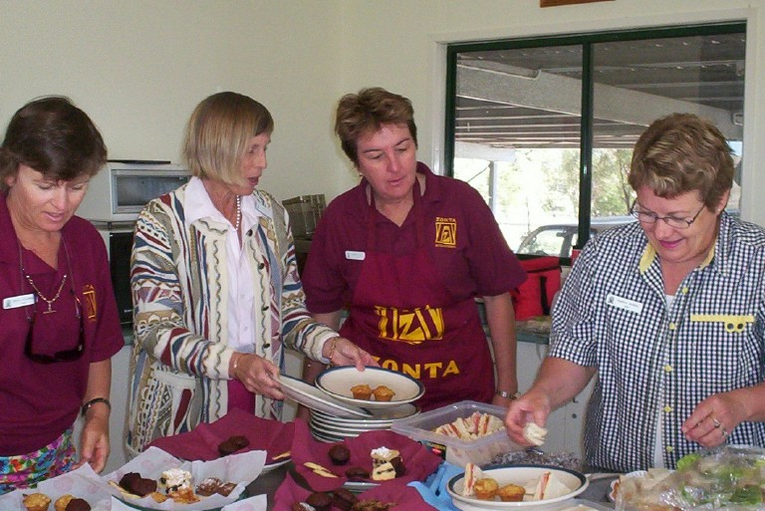

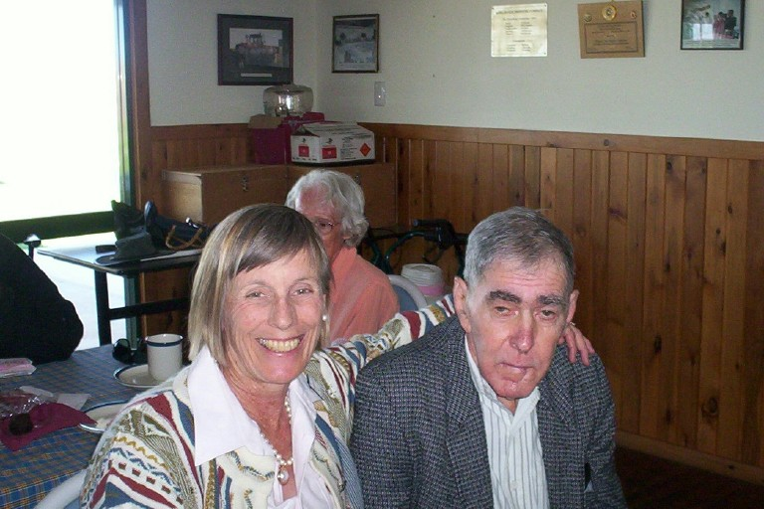

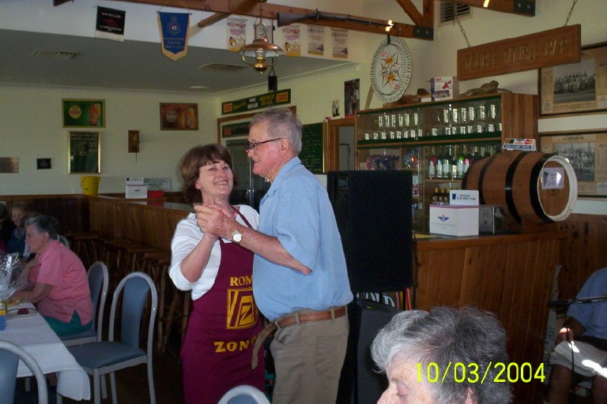

I was very impressed by the PR coverage of our Pamper Day. The local paper, thanks to Ros Kirby, was very generous with their lead-up story and good on you President Kim. You are a brave girl!
Hopefully, I’ll have some Pamper Day photos in next month’s newsletter. What an event that turned out to be! Well done to everyone concerned. I’m sure Denise and Andrea are relieved that the day turned out to be such a success.

We will now be looking at a day and a venue to sew some more breast cushions. Although it’s “head down” most of the time, we always manage to fit in plenty of nattering and a few smokos.

See you all on Tuesday.

Judy Bryant
Chairman – Program & PR Committee

Dates to Remember

- Tuesday October 26 – Smart Women – Smart Leaders Seminar from 9.am till 12 noon at the Grazier’s Building in Wyndham Street, Roma.

- Tuesday October 26 – Dinner Meeting from 6.pm at the Maranoa Club.

- Week beginning November 8 – Committee meetings to be held.

- Tuesday November 16 – Board Meeting at the Maranoa Club at 5.30pm.

- Tuesday November 23 – Dinner Meeting at the Maranoa Club at 6.oopm. International Night.

- Saturday December 11 – Zonta Christmas Party at Heather Hall’s.

october meeting

Will be held at the Maranoa Club on Tuesday 26 October 2004

Please contact Andrea Clancy
Phone 4622 8888 (w)
or
4522 2485 (h)
if you are unable to attend

In the absence of an apology,

an invoice for $14.50 will be sent to Non-Attending members to cover the cost of their meal.

OCTOBER ROSTER

duty | zontian
Blessing | Katie
Objects | Terri
Raffle | Terri & Suzanne
MOW (27th) | Jill F

Have you been reading your Zontian?
- Page 3 - The International President Mary Ellen Bittner’s report outlines clearly for us what our Club’s goals should be. She also states our 2004-2006 International Service Projects.
- Page 7 – The Foundation President Gerda Senkyr outlines contributions required to meet the Foundation’s commitments for the Biennium 2004-2006 and emphasises the role all Clubs play in meeting those commitments.
- Page 9 – United Nations International Chairman Jackie Shapiro’s report. Since many of us met Jackie on her visit to Roma, it is good to be able to put a face to her message.
- Pages 10 to 13 – Reports on International Programs
- Page 15 – Some creative Service Projects from Clubs around the world.
The Program & PR Committee will expand on these and other pieces of Zontian news at Tuesday’s meeting so bring your Zontian along and scan with us!

WHY ????

- Why does someone believe you when you say there are four billion stars in the sky, but check when you say the paint is wet?
- Why do we press harder on a remote control when we know the batteries are flat?

