

EMAIL- southerngoldcoasttweed@zonta district24.ogg

.
Correspondence/Newsletter: Merle Stephen (H: 55980409 Email libra@qld.chariot.au)

DATES TO REMEMBER

16th October DINNER MEETING

DINNER MEETING DETAILS

MONDAY 18th September
GREENMOUNT RESORT COOLANGATTA

6-30, FELLOWSHIP
COST $25
APOLOGIES MERLE STEPHEN BY SUN 17th 7PM

FAILURE TO DO SO MEANS YOU WILL BE CHARGED FOR DINNER
55 980409 libra@qld.chariot.net.au

ZONTA BIRTHDAY
SHERLEE WHIPPS

THOUGHT OF THE MONTH
Whether you believe you can do a thing or believe you can’t,
you are right.

Henry Ford 1863-1947

PRESIDENT’S MESSAGE

Once again our Car Rally was a success, with members from Gold Coast and Lismore Zonta Clubs joining us in the fun. Kerry and Merle chose a different route through the Tweed and Kingscliff areas and finishing up at a park in Tugun for a lovely BBQ organized by Janet. Whilst having a good time we were able to raise funds for the Kingscliff TAFE bursaries, which is much needed and appreciated by the recipients.

We have a guest speaker at the September dinner meeting. Melissa Medina will be speaking to us on Organ / Tissue Donation and Transplantation. Melissa is the Regional Donor Coordinator for the Gold Coast and will provide truthful education and de-mystify the topic. So please ask your friends to come along a listen to Melissa as I am sure she will be very interesting.

We are organizing a Direct Factory Outlet Shopping Day to Brisbane on the 4th November. Once again ask your friends to join us on a fun day out which will include the bus trip, morning tea and lunch as well as buying Xmas presents, clothes, shoes etc etc etc. Don’t miss out on this wonderful opportunity to buy up big at bargain prices.

We have a few other events in the pipeline such as the Xmas Party and we will also be forming the IWD Committee at the September meeting, so come along and be part of organizing these events.
LESLEY

FIRST PRIZE PRESENTATION BY CAR RALLY
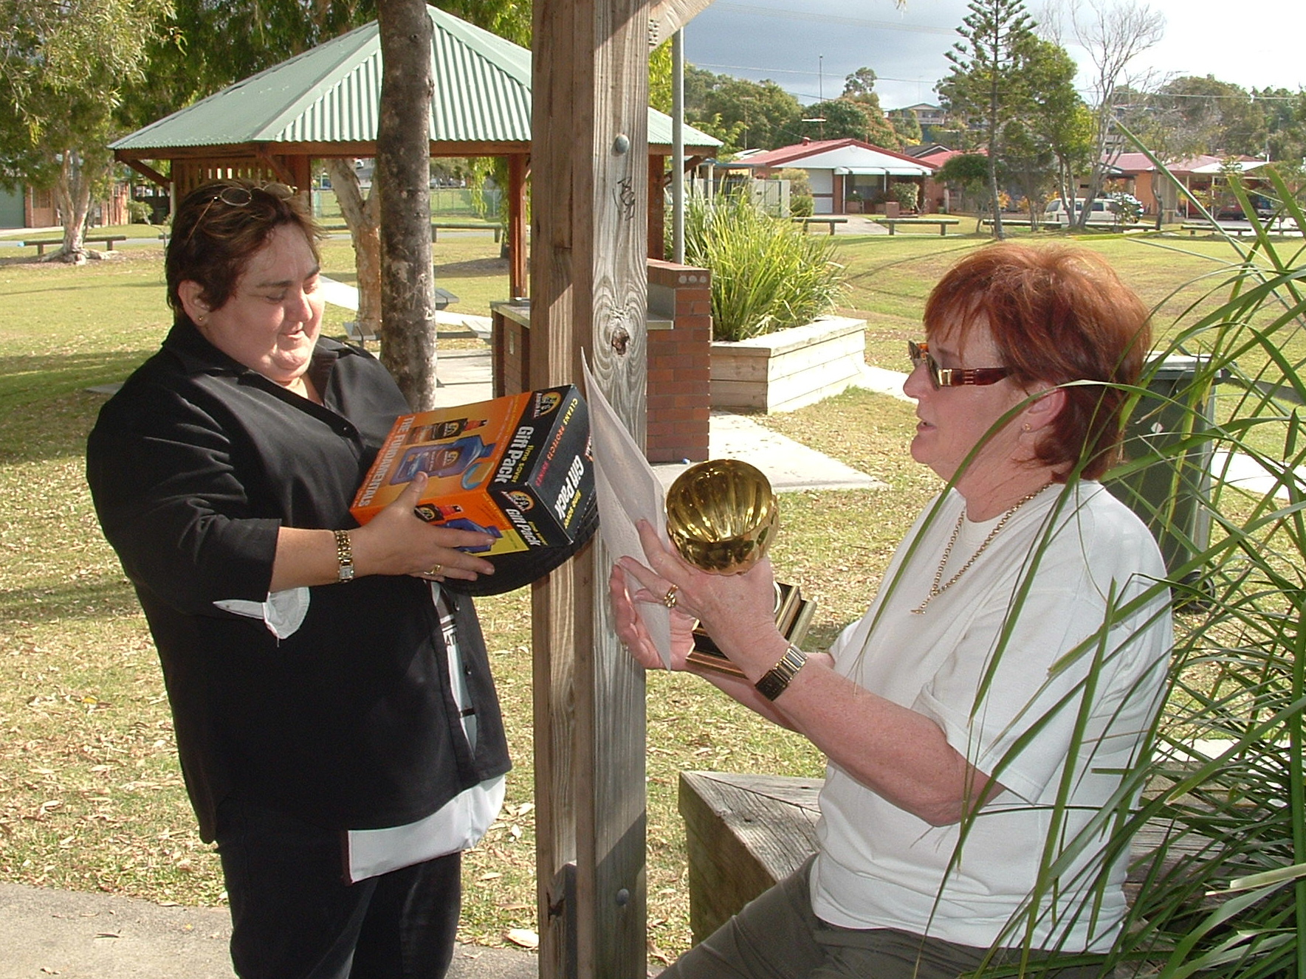 ORGANISER JANET, CHEF JOHN, & DAD
ZONTA CUP WINNERS LISMORE
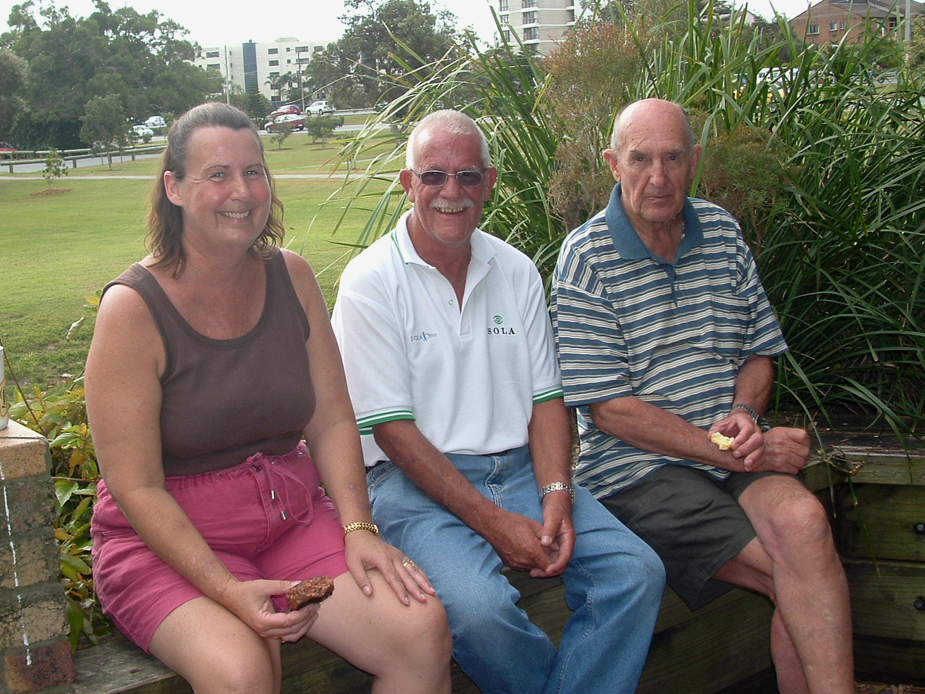
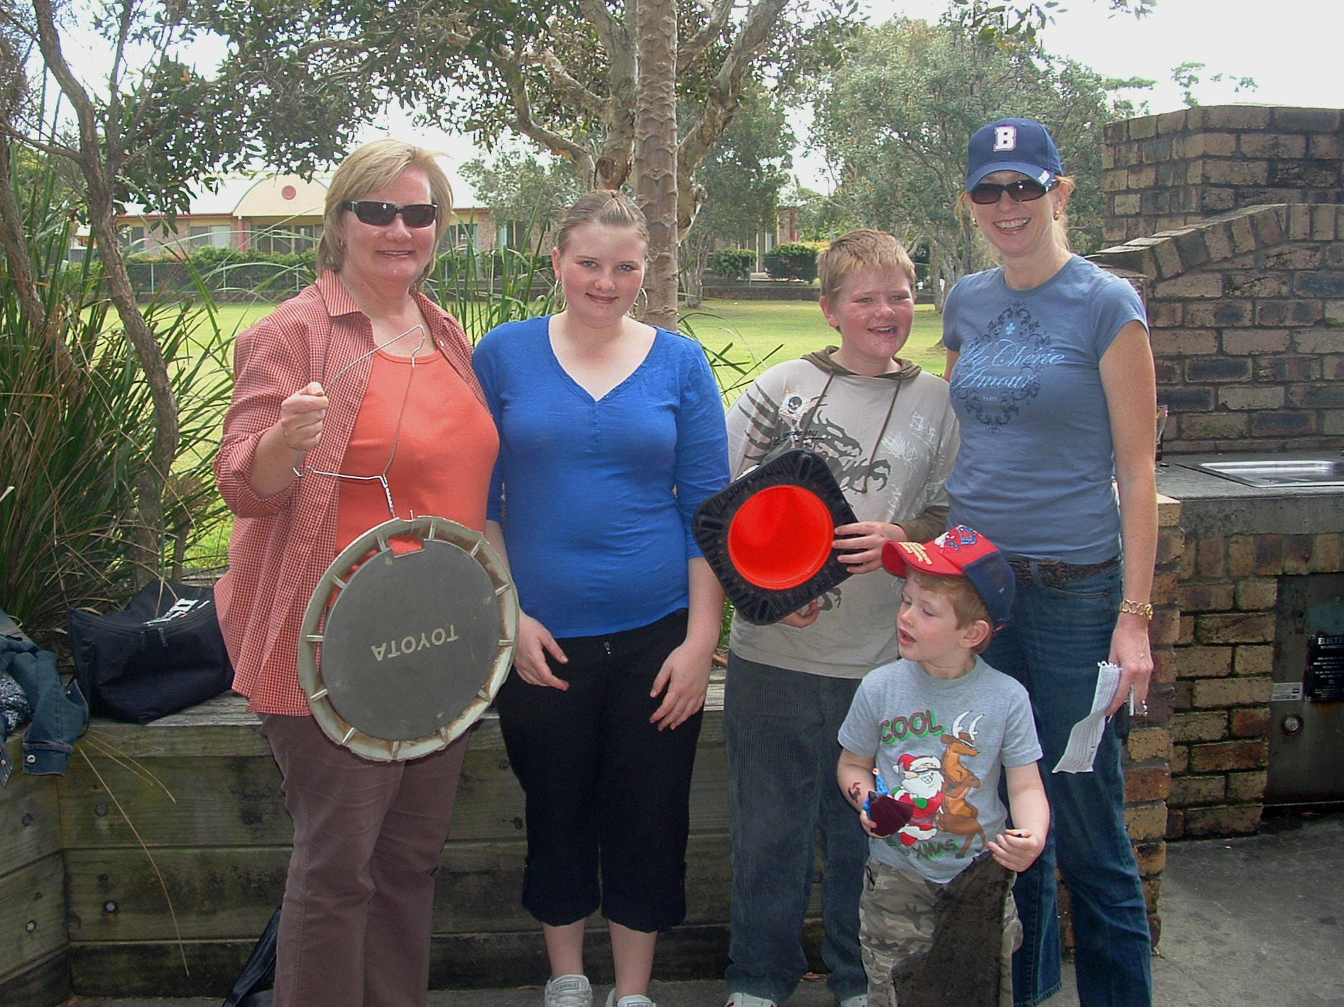

BRAS FOR CANCER
When your OLD bra is no longer supporting you then put it to good use – and let it support Breast Cancer Research instead.
Gold FM 92.5 will once again be collecting Bras for Cancer in October this year ($1.00 for each bra donated / collected)
But why wait until then?
Lets start collecting now!
Tell your friends!
Tell everybody
PLEASE bring Bras To next Dinner Meeting
Thanks
MERLE

