
July 2007

Zonta Club of
West Moreton Inc.
Inside this Issue
1 | From the President
2 | Zonta Events  Reminders
3 | Committee Reports and Notices
4 | Member and Other News
Our Club Website:

http://westmoreton.
zontadistrict24.org/

Our Club Email:
westmoretonzonta@yahoo.com.au
Zonta Club of West Moreton Inc.
PO Box 505
Ipswich Q 4305
Club No. 0900 District 24 Area 6


From the President

Dear Zontians,

We’ve had another productive month!

All is going ahead well for the Heritage Homes tour under the competent direction of Pam Lane, Bev Johnston and their team. Thanks also to those of you who have volunteered your time and talents to assist with preparing, baking and serving lunch and morning tea! Thank you also to Pat Evatt for offering her home for display on the tour and to Tina Kelly for hosting the lunch in the gardens of her home.

Ongoing club discussions have given rise to possible local community organisations that we could support during this Zonta year, which are consistent with “advancing the status of women”. Currently, Maria and Tina are gathering additional information regarding Hannah’s House and have arranged to tour this facility.

The Area 6 workshop will be happening in Ipswich before we know it! It is planned to be held in February, and hosted by our club. The first meeting of the organisational committee is due to be held soon, and Robyn and Cheryl will be calling for additional members to assist them—particularly members who have previously attended and/or assisted in organising past Area 6 or District 24 events.

Our club is continuing to have a positive and growing profile in our community…particularly with recent features in the Queensland Times regarding Joie Dwyer’s contributions to Zonta over the past 27 years and a news story on the jumpers being made and distributed to babies in need.

The District 24 Conference will be held at Tweed Heads from September 7-9. Several members have expressed interest in the possibility of attending. It will be an excellent weekend and a good opportunity to become more involved in Zonta. Earlybird registration closes at the end of July. I would encourage any of you who are interested to attend!

Thank you to Dorinda and the Programme Committee for organising the upcoming “Christmas in July” themed dinner at the Workshops Rail Museum. It is sure to be an enjoyable evening! Please be sure to invite guests (RSVP to Robyn with these numbers as per usual).

Warm regards,
Amy

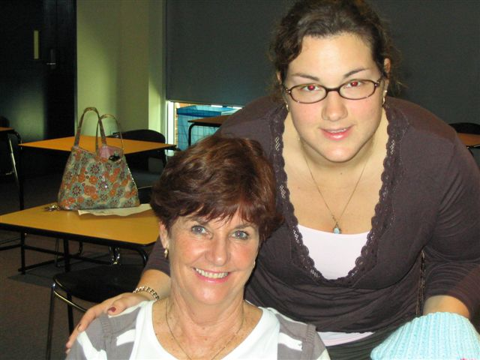

Amy and Margaret at the KICKZ knitting day!

JULY
MEETING DETAILS

Monday 23 July 2007
6.15pm for 6.45pm
at the Railway Workshops

Toast: Dorinda Baar
Grace: Leonie Peasey

IMPORTANT
please phone
Robyn Hargreaves
32889804

to

- advise apologies
- advise any special dietary requests
(e.g. a vegetarian meal)
- to confirm your attendance and guest numbers

before
7.15 am Friday 20
July

REMINDER: If apologies are not received by stipulated time of the meeting week, you are required to pay for the cost of the dinner. The Treasurer will send you an invoice.

REMINDER: If it is an ordinary night you only need to phone if you are NOT coming to the meeting … but if it is a guest night then ALL members should phone to indicate whether they are coming or not.

Heritage Homes
of Ipswich 2007 Tour

Sunday 22 July 2007
9.00 am to 3.30 pm

Arias at Sunset

Date: 27 October 2007

Zonta Board Announcement

At the last Board meeting of Zonta International, it was agreed that a
ZI position paper would be developed. This position paper is titled:
"Improve the access of women and girls to math, science and technology education".

The ZI International LAA Sub Committee is in the process of defining the scope of the project.

They are calling for expressions of interest from appropriately
qualified members of ZI to contribute to the Sub Committee's research
efforts. They are particularly looking for experts in the topic who can
assist in the preparation of the paper.

In turn, I am asking the Area directors to send an e-mail to your clubs seeking nominations from suitably qualified members; or if the members know of other people who would be prepared to lend their expertise.
Nominations are to include the contact details as well as a sentence or two outlining their area(s) of expertise. If the members could

reply directly to me that would be great (dorothy.koukari@railcorp.nsw.gov.au).

Could you ask that the members respond no later than close of business,
Thursday, 19 July 2007. I need to submit this information to Zonta
International

I believe that this is a wonderful opportunity for Australian women to
get involved in an important issue and I would love to see many District 24 members assisting in the compilation of this paper!

Dorothy Koukari
LAA Coordinator
Zonta International District 24

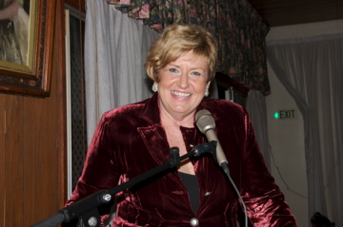

Gaye Anderson presenting a tribute to Joie Dwyer at the June meeting
Committee Reports and Notices

Finance and Fundraising Committee

I am absolutely delighted to be Co-Chair of the Finance and Fundraising Committee for this new Zonta year.

The majority of members in this committee have been Zontians for many years and have been involved in many projects and fundraisers. This gives me a perfect opportunity to learn and be mentored as well as a great opportunity for personal growth.

Our first general meeting of the new Finance and Fundraising Committee is to be held on Monday the 6th August 2007 at 6.30pm. Pam Lane has offered her home along with her culinary skills for this meeting. Members please contribute $10 per head for our dinner and please RSVP to me by Friday the 3rd August. a.mcgrath@recruitmentqld.com.au or 0403 065 756.

The Ipswich Musical Theatre Company is presenting “South Pacific”-a haunting South Sea love story that blossomed during wartime in a towering musical masterpiece. This has been booked for 30 people for Friday the 14th September. As numbers are limited please book your ticket as soon as possible to avoid disappointment. Tickets are $28.00 per person.

By the time we receive this newsletter the Heritage Homes

Tour will be imminent. Many hours of work and organisation have again gone into this impressive event and I congratulate Bev Johnston and her many helpers and look forward to this event.

Alison McGrath

Late payment of memberships
Overdue annual fees

Can all outstanding memberships please be paid by 23 July 2007 (next general meeting) to enable finalisation of the monies to Zonta International and District 24. Fees were due 1 April 2007 and I would like to clear the balance of the paperwork.

Maria Kelly

Dinner Monies

With reluctance I have recently been sending out invoices for members whose apologies for dinner were not received, or not received in sufficient time, for us not to be charged for the meal (too many “nots” in there!!!). After numerous years of flexibility the Ipswich Club is taking a firm stance on its policy of charging us for the number we booked for. Can you please stay in contact with Robyn re: apologies or give the Club sufficient time (if possible) to avoid these costs. Else: an invoice will be winging it’s way to a post box near you.

Maria Kelly

10,000 Club

Yes, the “gold” raffle is finally about to be officially launched. At July’s meeting we will be announcing the “10,000 Club”. Tickets are being printed and a leaflet is being prepared. Heritage Homes attendees will be offered the opportunity to contribute to this fundraising initiative of our club. Tickets are $100 each and they are limited to 200.

Drawn: Zonta’s Christmas Party. First prize (only prize) $10,000.00.

Prior to the launch we have sold 18 (paid) and have another 7 waiting to be paid for i.e. 25 down, 175 to go!!!!! Maria and Tina will be the “management committee” behind this so please contact us for tickets/queries/etc.

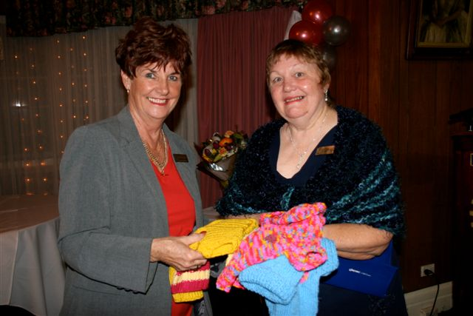
Member and Other News

HELP WANTED!!!

I’m looking to see if anyone can assist me with running a “canteen” at my mother’s Open Garden Days.

I’m looking for:

- Volunteers able to give two (2) hours on either a Saturday or Sunday to run the canteen and/or
- Volunteers to make slices to sell that weekend

My parents, Pat and Nev Kelly, are opening their garden under the “Open Garden” scheme on the weekend of 20 and 21 October (weekend before Arias). They live at 25 Macquarie Street Booval. Mum has quite an interesting garden both in her yard and, after moving the back fence twice, in the property behind her house.

When she mentioned that the Open Garden scheme organisers were keen for her to sell food/drinks I immediately jumped in as a fundraiser for Zonta however she had already offered this to the Auxiliary of Nowlanvil Nursing Home. The Auxiliary have now had to withdraw and she is looking for someone to organise this. Okay, big mouth (me) stepped in and said I would do it, with the assistance of my
work team and possibly Zonta members.

Can you let me know if you are available to make slices to sell (I’ll come and collect) or give two hours of time to “work the counter”?

And there’s more. This day will give you the opportunity to see a very interesting garden and maybe some ideas for your own backyards!!!

We are hoping that the funds can be contributed towards Nowlanvil (I’m still really keen on assisting with electric beds etc for the residents) however Mum understands that Zonta would prefer a cause that assists women solely.
Thanks. Contact me if any queries/interest.

Maria Kelly

Work 3812 2233
Home 3389 7710
Mobile 0418 786 121

Birthdays
Birthday organisers ….
3rd quarter – Kath Everett
(July August September)
4th quarter – Pat Evatt
(October November December)

KICKZ
Knit (for) Indigenous (and other) Cool Kids (with) Zonta

The KICKZ knitting day went off well with 5 knitters and Carolyn Maddox’s mum joining in to knit jumpers, beanies and leggings for babies from disadvantaged backgrounds. Many of the jumpers have already been distributed.

Below is a summary of where some of the Zonta baby jumpers have headed:

- Ngunytju Tjitji Pirni (near Kalgoorlie) - 5 jumpers

- Mookai Rosie Bi-Bayan (near Earlville) - 5 jumpers

- Aboriginal Medical Service, Canberra - 5 jumpers, 1 set leggings, 2 beanies

- Cherbourg Hospital - 15 jumpers

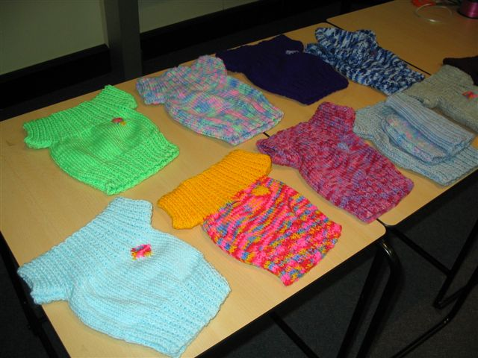

An example of the wonderful baby jumpers knitted by talented Zontians

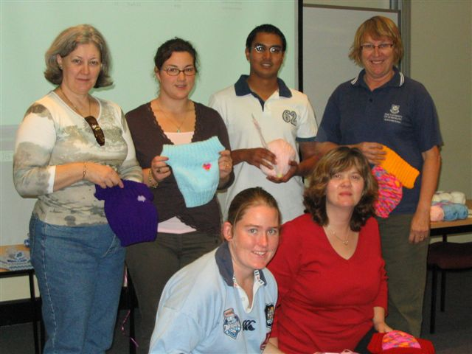

Some of the knitters who attended the KICKZ knitting day

…Some energetic Zontians including Margaret Llewellyn, Gaye Anderson, Pam Lane and Kath Everett will be participating in the Park 2 Park Walk in Ipswich on 29 July 2007!...

