
October 2007

Zonta Club of
West Moreton Inc.
Inside this Issue
1 | From the President
2 | Zonta Events  Reminders
3 | Committee Reports and Notices
4 | Member and Other News
Our Club Website:

http://westmoreton.zontadistrict24.org/

Our Club Email:
westmoretonzonta@yahoo.com.au
Zonta Club of West Moreton Inc.
PO Box 505
Ipswich Q 4305
Club No. 0900 District 24 Area 6


From the President

Dear Zontians,

Plans are coming along nicely for this year’s Arias at Sunset under the confident and enthusiastic direction of Pam Lane. Make sure to books your table ASAP, as greater attendance contributes to a more festive atmosphere on the evening!

An enjoyable morning of fellowship and service was recently held at Jennifer McMahon’s home this past month, making cushions for women who have undergone treatment for breast cancer. We were fortunate to have additional donations of books from a breast cancer survivor to add to the packages for area hospitals.

Arrangements are progressing well for our club to host the 2008 Area 6 Workshop early next year. Stay tuned for details of further planning from Kate Kunzelman and her committee.

Maria Kelly and Tina Kelly plan to attend the 25th Anniversary event for Hannah’s House, and arrangements have been made for some of the young women from Hannah’s House to attend Arias. Please contact Maria K regarding your additional raffle ticket sales. We are nearly at 75% of our goal—and we all have to keep working to achieve 100%.

Regretfully we will be saying farewell to Pam Smallwood on Friday, October 19th at the Ipswich Club and celebrating her move to the Sunshine Coast. We wish her and Des well, and will miss her valuable contributions to our club over the years! I hope many members are able to attend, as it will make for a lovely evening of reminiscing and fellowship.

The Board and Nominating Committee are the in the process of making handover arrangements, as I will be taking maternity leave from my role as president starting in December. Our

Christmas function will be the last of my official duties. I plan to remain a regular (and active!) member from January onward, although anticipate missing a couple of meetings in the New Year as we settle into our routine with Baby.

Hope to see you at the United Nations night for our October meeting!

Warm regards,
Amy

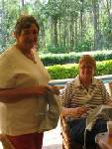

Jennifer and Kath and below Pam, Heather and Tina – all hard at work at the recent breast cushion making day

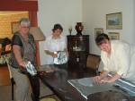

Zonta Event Reminders

OCTOBER
MEETING DETAILS

Monday 22 October 2007
6.15pm for 6.45pm
at the Ipswich Club

IMPORTANT
please phone
Helen Brodie
3281 3509

to

- advise apologies and confirm attendance
- advise any special dietary requests
(e.g. a vegetarian meal)

before
9:00am Friday
19 October 2007

REMINDER: If apologies are not received by stipulated time of the meeting week, you are required to pay for the cost of the dinner. The Treasurer will send you an invoice.

REMINDER: If it is an ordinary night you only need to phone if you are NOT coming to the meeting … but if it is a guest night then ALL members should phone to indicate whether they are coming or not.

Arias at Sunset

Date: 27 October 2007

International Day for the Elimination of Violence Against Women

White Ribbon Day 25 November is dedicated to the elimination of violence against women. It provides an opportunity for women and men to face up to this issue and find practical ways to help.

Wearing a white ribbon is a visible sign that the wearer does not support or condone the use of violence against women and is committed to ending it.

General enquiries: admin@whiteribbonday.org.au

This is a fantastic opportunity to show your support of the eradication of women's poverty.

Visit the web site www.womenfightpoverty.org
to find out more and register your support.

Stand up and speak out against poverty.

Open Garden

Through the Australian Open Garden Scheme at

Nev & Pat Kelly’s home

Place: 25 Macquarie Street, Booval
Date: Saturday and Sunday 20, 21 October 2007
Time: 10am to 5:30pm

$10,000 Club

A friendly reminder that there are still tickets in the $10,000 Club to be sold. Approximately 80 tickets remain (from 200) at $100 per ticket. We ask that all Zontians support this key fundraising initiative.

Drawn: Zonta’s Christmas Party. First prize (only prize) $10,000.00.

Programme

I hope that everyone who attended the Zonta Birthday Meeting enjoyed themselves. Toni Risson gave an informative presentation on the history of Greek Cafes in Ipswich. Several long term Ipswich residents enjoyed seeing the photos of the "Old Ipswich” and reminisced while viewing familiar faces, buildings that no longer stand and streets that have been altered.

For our next meeting the lovely ladies from United Nations have organized a guest speaker.

Dorinda Baar
Chairperson

Public Relations

Communications
Newsletter

The newsletter committee met at Fed Up and it was our last meeting with Pam Smallwood so it was hard to keep us on to the topic of why we were there. Pam delivered jumpers knitted by herself, her daughter and her sister. Anne Matyear
took them with her for distribution.
I now have a contact at the QT and have arranged for them to do a story on our Breast Cushion Day. Pam Lane arranged for the photos to be given to the QT on disc
so a big thank you to Pam.
Don't forget Friday afternoon at the Ipswich Club to say goodbye and to say thank you to Pam Smallwood for her contribution to our club.

Margaret Llewellyn
Chairperson

Finance
Fundraising

Sponsorship

“Arias at Sunset” – Saturday 27th November 2007. This is certainly an evening not to be missed as it is not only a beautiful evening of entertainment but a great social evening also. If you have not booked your table as yet please do so urgently to Pam Lane.

Unable to make up a table? We will happily organise for you to join one.

We will have our list of volunteers available at our next Zonta dinner. If you are unsure what duties you have been assigned with or would like to volunteer to assist please speak with me.

By all accounts the “South Sea Musical” was a great success with all attendees thoroughly enjoying the evening. Thank you to all who supported this evening.

Alison McGrath
Chairperson

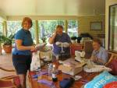

Marie, Jan and Margaret at the breast cushion making day

2008 area 6 conference

The sub-committee for the organisation of the 2008 Area 6 Conference, which is to be hosted by Zonta West Moreton, has been making terrific progress under the leadership of Kate Kunzelmann. Our thanks to Jan Ackroyd-Bailey who has kindly opened her home each fortnight for the meetings.

All Zontians please keep Saturday 5 April 2008 and Sunday 6 April 2008 free as this is when the Area 6 Conference is to be held. The sub-committee has decided on Woodlands as the venue for the conference and other arrangements for the weekend are underway. We will keep you updated in future newsletters.

Member and Other News

Update from Kirsty Sword from East Timor

What follows is an email from Kristy to Maria Stevenson…

Dear Maria and Richard,

I just wanted to let you know that I had the great pleasure on 15 September of handing over the first tranche of funds ($US 1,200.00) from the Rotary Club of Ipswich for the Luzeiro Women's Literacy Project. Albina and her team were extremely grateful for this support which is the most significant grant their organisation receives for their work. We will make the second tranche available upon presentation of a 6 month progress report on the project. We do hope that the Rotary Club of Dili will be able to visit the project site at some point in the coming months to give you their own assessment of its impact on the educational status of local women.

Did you receive the report and documentation I posted to you recently?

Attached please find a photograph which was taken at the time of presentation of the funds to Ms Albina Freitas.

With kind regards,

Kirsty Sword Gusmao
Chairwoman
The Alola Foundation

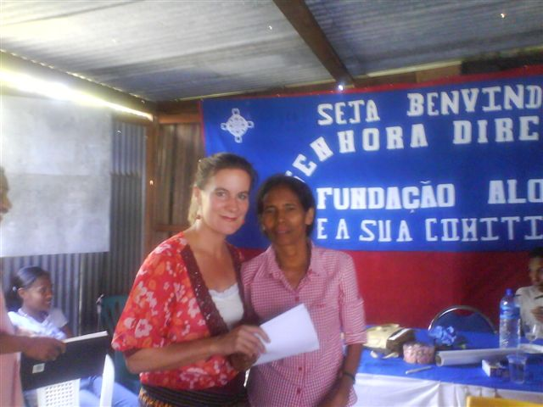

Other news…

Pam Smallwood and her friends and family have been in production mode. Between them they have produced 63 jumpers, 3 beanies and 1 pair of booties. Congratulations Pam on this amazing outcome. As usual you have put in 110%. You will be sadly missed when you move to your new home up the coast.

The Birthday Girls went to dinner at Fentons. We had a lovely evening getting to know one another better. As an outcome of this evening we have formed a Book Club and have had our first meeting. The dinner and book club have been a great source of fun and fellowship. Each Zontian shared a book that they had found interesting or had enjoyed. This experience revealed what a diverse and interesting group of women we have in our club. Breast cushion day was also a wonderful opportunity for fellowship.

Jennifer Mc Mahon will be finishing her studies this year and is planning a celebration to mark the occasion.

Welcome back to the recent travellers; Dianne, Gaye, Pat, Leonie and Anne. Hope you had some wonderful experiences and share these stories with us.

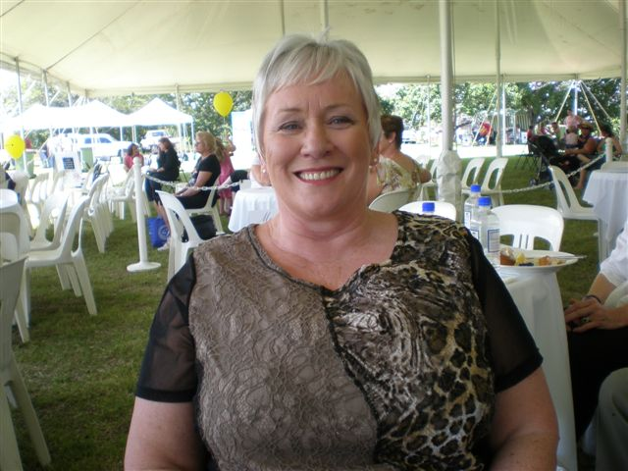

Our hardworking Pam Lane enjoying some time out

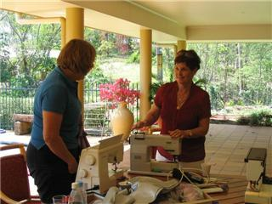

Margaret and Marie at the breast cushion making day!

